Talent Pull Website Content:
- Connecting the right talent to the right opportunities - every time.
- Connecting reliable talent with opportunities that drive results
- POWERING YOUR WORKFORCE, THE SMART WAY.
Get to Work with the Leading Recruitment Agency in Canada
- A trusted Canadian staffing partner helping businesses and careers thrive by connecting qualified talent with opportunities across multiple industries.
- Providing reliable workforce solutions across manufacturing, logistics, cabinetry and professional sectors - fast, flexible, and scalable.
Browse Jobs Contact Us
The Talent Pull Advantage
At Talent Pull Inc., we go beyond recruitment, we deliver strategic workforce solutions that help businesses scale efficiently, reduce hiring risks, and build high-performing teams.
- People-First Approach with Strategic Insight:
We bring a people-centric strategy to every engagement, aligning talent with your business goals. Our approach ensures not just placements but long-term success, productivity, and team stability.
- Time & Cost Efficiency:
Save valuable time and reduce hiring costs with our end-to-end recruitment support. From job postings and candidate screening to interview coordination, we handle the entire hiring process so you can focus on your core operations.
- Access to a Strong Talent Network:
Gain access to a wide pool of pre-screened, job-ready candidates available for temporary, contract, and permanent roles. Our active sourcing approach ensures you connect with qualified talent fast.
- Compliance, Safety & WSIB Coverage:
We ensure every placement meets Ontario employment standards and workplace safety requirements. From WSIB coverage and compliance to certifications and onboarding, we manage it all giving you peace of mind.
- Faster Hiring & Reduced Risk:
Our team specializes in quickly identifying and engaging top talent, helping you fill critical roles without delays. With thorough background checks and credential verification, we minimize hiring risks and ensure quality placements.
- Industry-Focused Expertise:
With hands-on experience across manufacturing, warehousing, skilled trades, and professional roles, we understand your workforce challenges and deliver solutions tailored to your industry.
Services Section:
Break into:
- Permanent Recruitment:
Headline: Find the Right Talent Faster!
Content: Secure top-tier candidates for permanent roles with our targeted recruitment approach. Talent Pull Inc. leverages industry expertise, active sourcing, and a strong talent network to identify professionals who align with your business goals.
From skilled trades to administrative and finance roles, we deliver candidates who are ready to contribute from day one.
- Temporary & Contract Staffing:
Headline: Reliable Temporary Staffing - When You Need It Most!
Content: Access pre-screened, job-ready talent to meet your short-term workforce needs. Whether you're managing seasonal demand, covering absences, or scaling production, Talent Pull Inc. delivers qualified temporary staff quickly and efficiently.
We specialize in providing reliable, fully vetted, and WSIB-covered dependable workers across manufacturing, warehousing, logistics, and administrative roles ensuring minimal downtime and maximum productivity.
- Temp-to-Perm:
Headline: Hire with Confidence - Try Before You Commit!
Content: Our temp-to-permanent staffing solution allows you to evaluate candidates on the job before making a long-term hiring decision.
We handle sourcing, screening, and onboarding, so you can focus on performance before transitioning top talent into permanent roles.
- Payroll & Compliance Management:
Headline: Seamless Payroll & Compliance - Fully Managed!
Content: Simplify your workforce operations with our end-to-end payroll and compliance management services. Talent Pull Inc. ensures accurate payroll processing, statutory deductions, and full compliance with Ontario labour laws and regulations.
From timesheet management to CRA requirements, we handle the administrative burden, so you can focus on running your business with confidence.
- Health & Safety Training:

Headline: Workforce Safety Starts Here!

Content: We prioritize workplace safety by ensuring all candidates are properly trained and compliant before stepping on-site. Our onboarding process includes WHMIS certification, workplace hazard awareness, and essential health & safety training aligned with Ontario standards.

Protect your workforce, reduce risks, and maintain compliance with our safety-first approach.

- Bookkeeping Support:
Headline: Reliable Bookkeeping Support for Your Business!
Content: In addition to staffing solutions, Talent Pull Inc. offers bookkeeping support to help businesses maintain accurate financial records. From accounts payable and receivable to basic financial tracking, we provide dependable support tailored to your operational needs.
Ideal for small to mid-sized businesses looking for efficient and cost-effective financial administration.
Specialists in Cabinetry & Manufacturing Staffing
Talent Pull Inc. specializes in providing reliable temporary staffing solutions for cabinetry and manufacturing environments. We understand the unique demands of production floors, including tight deadlines, skilled labour requirements, and operational efficiency.
From CNC machine operators and cabinet assemblers to general labourers and maintenance technicians, we deliver pre-screened, job-ready candidates who can contribute from day one.
Our strong presence in the manufacturing sector allows us to respond quickly to workforce needs helping businesses maintain productivity, meet production targets, and scale with confidence.
Industries We Serve
From hands-on labour to specialized professional roles, we support companies across multiple industries with reliable hiring and fast turnaround. Wherever the talent gap is, we help you fill it.
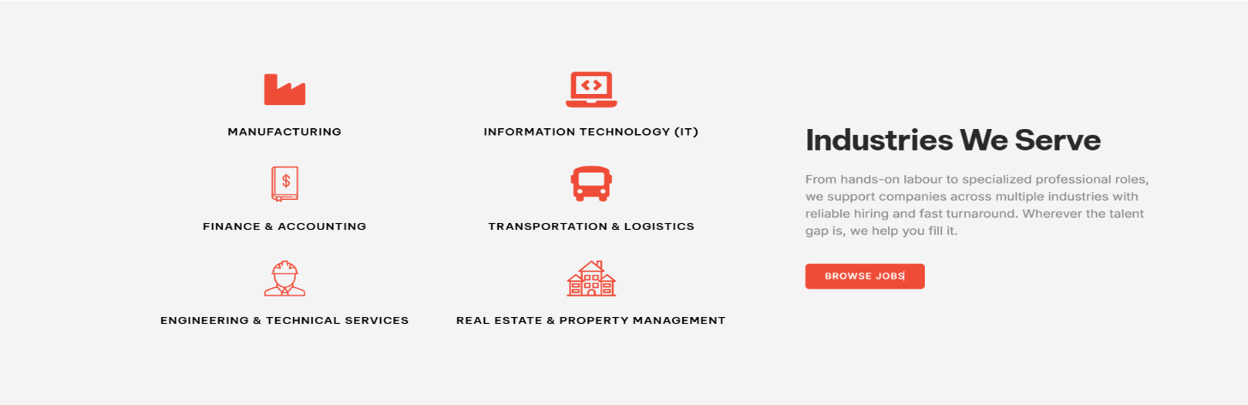

Industries:
- Cabinetry Manufacturing
We support cabinetry and wood manufacturing facilities with skilled operators, CNC machine operators, assemblers, and production staff experienced with industry-leading equipment and processes.
- Rugs & Carpet Manufacturing
Providing dependable labour for high-volume production environments, including machine operators, forklift operators, maintenance technicians and general labourers to support efficient manufacturing operations.
- Warehousing & Logistics
We supply experienced warehouse associates, forklift operators (reach, counterbalance), order pickers, and shipping/receiving staff to keep your operations running smoothly and efficiently.
- Accounting & Finance
From accounting assistants to full-cycle accountants and finance professionals, we connect businesses with talent skilled in financial reporting, AP/AR, payroll, and compliance.
- Skilled Trades
We recruit qualified trades professionals including maintenance technicians, machine operators, and other skilled workers essential for manufacturing and industrial environments.
- Real Estate
Connecting real estate firms and property management companies with administrative, accounting, and operations support staff to manage day-to-day business functions effectively.
- Information Technology (IT):
Supporting roles within the Ontario Public Service, providing qualified candidates for IT positions. We understand the compliance, structure, and hiring processes required for public sector engagements and deliver talent aligned with government standards.
Take the next step in your career with Talent Pull Inc.
Join a network of skilled professionals, discover meaningful opportunities, and get matched with employers who recognize your potential.
Explore Opportunities
Job Listings:
Candidate Application form under each listing:
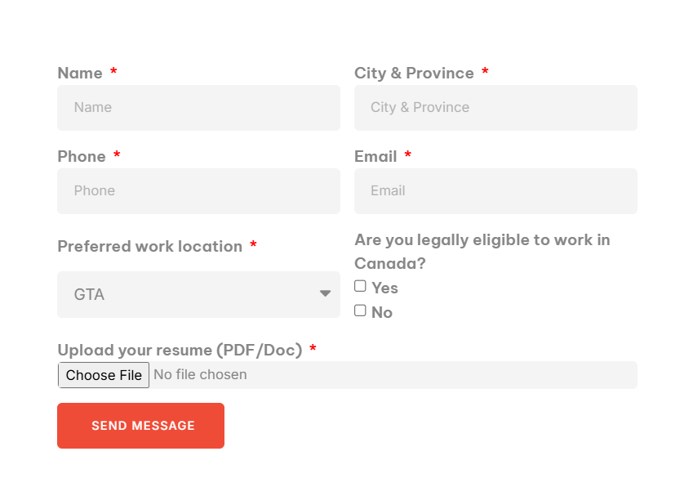
Frequently Asked Questions (FAQ):
- What types of staffing services do you offer?
We provide temporary staffing, temp-to-permanent hiring, direct hire recruitment, and on-site workforce solutions tailored to your business needs.
- How quickly can you fill a position?
We leverage our network of pre-screened, job-ready candidates to fill most roles quickly often within 24 to 72 hours depending on the position and requirements.
- What industries do you specialize in?
We support a wide range of industries including warehousing & logistics, cabinetry, rugs & carpet manufacturing, accounting & finance, real estate, and public sector.
- Do you handle payroll and compliance?
Yes, we manage payroll processing, statutory deductions, WSIB coverage, and compliance with Ontario employment standards reducing your administrative burden.
- How can I apply for jobs through Talent Pull Inc.?
You can apply directly through our website by submitting your resume or browsing open positions. Our team will match you with roles that align with your skills and experience.
- Will I receive training before starting a job?
Yes, depending on the role, we provide or verify required training such as health & safety, WHMIS, and job-specific certifications.
Address: 5063 North Service Rd suite 100-511, Burlington, ON L7L 5H6
Email ID: info@talentpull.ca
Contact Number: 647 808 2716

